Duy Tan University – Capstone

29 August 2012
DATABASE DESIGN DOCUMENT
Online Judge

Table of Contents

Project Proposal

Introduction
Design database provide the basis for the design of database systems dt-online-jam. It defines the database will support the function dt-online-jam Data Model. It describes both logical and physical definitions, problems, functionality and database interface; storage aspects are defined in the physical database design. The design was created with the expected volume of data, functional and non-functional use of tables.

Scope
- Database design for the system functions including definitions for
database objects, attributes to the table, define the data relationships in the system.
- In the design process, the original definition is enhanced to support functions
described in the specifications / use cases and functions specified in the support function module design.

Related Documents

This specification refers to the following documents:
• dt-online-jam project plan website
• dt-online-jam requirements document website.

Sub application/Application Overview

- Dt-online-jam is the ultimate online article on websites, but all students in general and students only Front particular can manage the system questions, tests and results.
- Students can choose to test systems and solve anytime and anywhere just have a computer connected to the internet.

5. Hardware and Software Architecture

- This section provides an overview of the hardware and software architecture.
The following describes the system components websites.
The system components websites dt-online-jam:
Attribule | Description
Design | HTML5
Platform | Windows, Linux
Database | SQL Server
Software | Microsoft Visual Studio
Hardware | - Core i  - RAM 1G  - HDD 250G

6. Introduce about SQL database management system

6.1 Introduce:

- SQL is a database management software (DBMS) such as MySQL, PostgreSQL.

- The features of SQL is a simple compact. The program includes a file with very small size, no installation, no configuration or boot that can be used immediately.

- The data is stored in a database file. Concept of user or password, SQL database rights.

- SQL suitable for large systems / applications, but in the mid-range boost SQL is strong and not weak or speed functions. With the features of SQL is used in the development, testing and appropriate choice for database beginners system.

6.2 Constraint:

• Support for popular languages: C++, Java ...
• No need to define the type of data (SQL)
• Support UTF8 code.
• Command line support.
• Support for the transaction.
• Support for display.
• Tools for graphics.
• Download and use for free.

6.3 Version:

There currently are 2 different branches of SQL server version 2008, 2010, 2012 internal data structure no different to the command name and the name of each different library branch.

http://www.microsoft.com/sql/

7. Database Design Decisions

- This section includes the decision was made when designing the database for dt-online-jam. Issues, alternatives and options are listed below.
This section also lists any design assumptions were made. In the case of
This assumption is the result unclear or lack detail, they will need to verify group analysis.

7.1 Assumptions

- A number of assumptions due to a lack of information will be updated in the next version of database design document.

7.2 Mapping rules

When mapping the desktop unit, the following rules apply:
• Objects are mapped to tables 1-1.
• Attributes are mapped to columns 1-1.
• One-to-many relationship is mapped to the foreign key.
• Many-to-many relationship is done by using two intersecting one-to-many relationship with the table (if have).

8. Table Relationship Diagrams

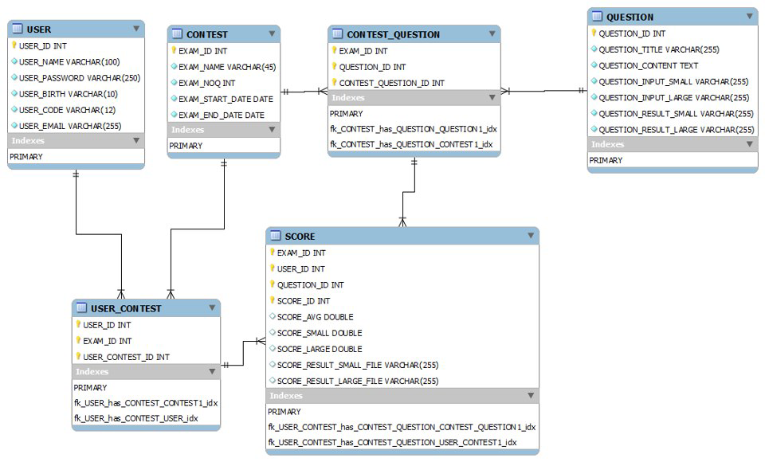

8.1 Description of Table

a. User table:
No. | Field | Type | Length | Null/Not Null | Key | Default | Description
1 | User_ID | Int |  | Not Null | Primary |  | Index of table User.
2 | User_Name | Varchar | 100 |  |  |  | User_Name to login into the system.
3 | User_Password | Varchar | 250 |  |  |  | User_Password to login into the system.
4 | User_Birth | Varchar | 100 |  |  |  | Display personal birth
5 | User_Code | Varchar | 12
6 | User_Mail | Varchar | 255 |  |  |  | Display personal mail

b. Contest table:
No. | Field | Type | Length | Null/Not Null | Key | Default | Description
1 | Exam_ID | int |  | not null | primary |  | Index of table User.
2 | Exam_Name | varchar | 45
3 | Exam_NQQ | int
4 | Exam_Star_date | date
5 | Exam_End_date | date

c. Contest_Question table:
No. | Field | Type | Length | Null/Not Null | Key | Default | Description
1 | Exam_ID | int |  | not null | foreign
2 | Question_ID | int |  | not null | foreign
3 | Contest_Question_ID | int |  |  | primary

d. Question table:
No. | Field | Type | Length | Null/Not Null | Key | Default | Description
1 | Question_ID | int |  | not null | primary
2 | Question_Title | varchar | 255
3 | Question_Content | text
4 | Question_Input_Small | varchar | 255
5 | Question_Input_Large | varchar | 255
6 | Question_Result_Small | varchar | 255
7 | Question_Result_Large | varchar | 255

e. User_Contest table:
No. | Field | Type | Length | Null/Not Null | Key | Default | Description
1 | User_ID | int |  | not null | foreign
2 | Exam_ID | int |  | not null | foreign
3 | User_Contest_ID | int |  | not null | primary

f. Score table:
No. | Field | Type | Length | Null/Not Null | Key | Default | Description
1 | Exam_ID | int |  | not null | foreign |  | Index of table User.
2 | User_ID | Int |  | Not Null | foreign |  | Index of table User.
3 | Question_ID | int |  | not null | foreign
4 | Score_ID | int |  | not null | primary
5 | Score_AVG | double
6 | Score_Small | double
7 | Score_Large | double
8 | Score_Result_Small_File | varchar | 255
9 | Score_Result_Large_File | varchar | 255

